|  |  |
| --- | --- |
|  | |
| Primary Actors: | *Administrator* |
| Importance Level: | *Low* |
| Stakeholders: | *Admin – needs to upload course syllabus* |
| Requirement Id: | *UF-1* |
| Requirement: | *Syllabison shall allow the administrator to upload course syllabi* |
| Quality Requirements: | *The upload preview screen should render in three seconds* |
| Story: | *As an Administrator, I want to upload course syllabi, so that it can be accessible to users of Syllabison.* |
| Pre-Conditions: | *I am on the ‘enter syllabus details’ screen* |
| Post-Conditions: | *The syllabus details are updated on the ‘enter syllabus details screen”* |
| Trigger: | **Trigger Type:** *External*  *Admin clicks on ‘Upload Syllabus’ option* |
| Normal Flow of Events: | 1. *Syllabison responds with a file upload dialog screen*   ***Extension Point: Browse for File***   1. *I choose a file*    1. *PDF* 2. *Syllabison updates the file on the enter syllabi details screen* 3. *Syllabison responds with the uploaded syllabi* |
| Sub/Alternative/Exception flows: | ***Alterative 1:***   1. *I select ‘cancel’* 2. *Syllabison responds with the enter syllabus details screen* |
| Exception | ***Exception 1 – File size too large***   1. *Syllabison shall displays an error message explaining the error.*   *1.1 “The file selected is too large”* |
| Extension Point | ***Browse for File***   1. *I select the ‘choose…’ button* 2. *Syllabison responds with a Choose File dialog* 3. *I choose a file*    1. *PDF* 4. *Syllabison updates the file on the enter syllabi details screen* |
|  | |

Scenarios

**I successfully upload a syllabus**

1. I am on the enter Syllabus Details screen
2. I select the upload syllabus option
3. I see upload preview screen
4. I select choose
5. I choose a “Math 101.pdf”
6. I select upload
7. I see the enter syllabus details screen is updated with the “Math 101”

**I exit upload preview screen**

1. I’m on the ‘enter syllabi details’ screen
2. I select the upload syllabi option
3. I choose a new file
4. I select cancel
5. I see the syllabus details screen

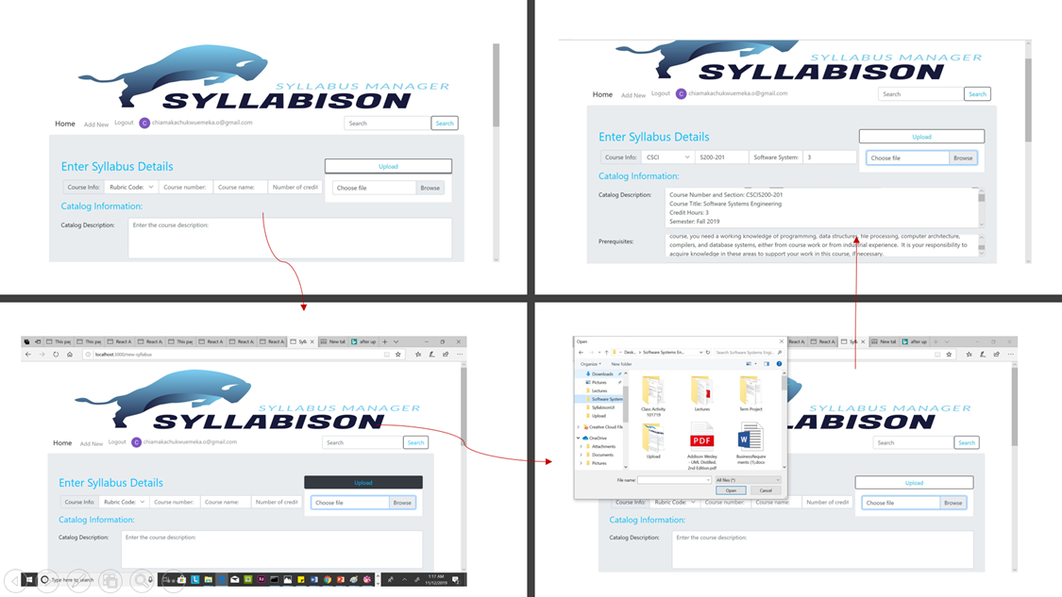

**UI Flow**